**Gym Management System**

**OODP Project**

**Presented By :**

Mohamed Hashish

Fatma Jamal

Abdelrahman Mahfouz

Nosiba Fatouh

Xeina Tamer

Hadeel Mahmoud

**UML Diagram**

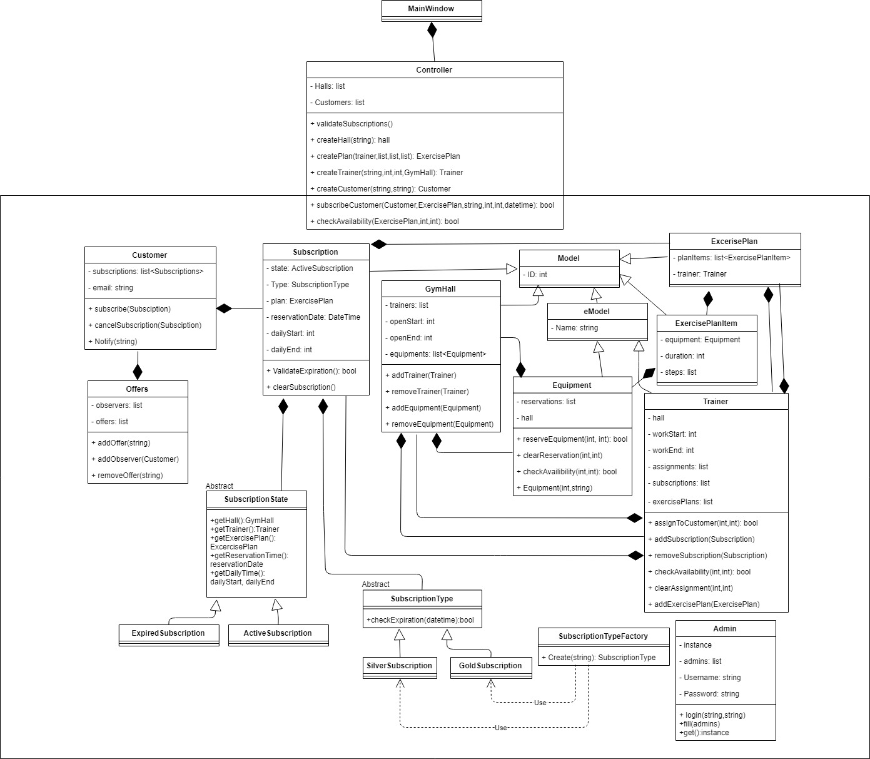

**Design Patterns Used:**

1. Façade Design Pattern

* Façade is a structural Design Pattern used in-order to encapsulate all the Models as it defines the Higher level interface that makes the subsystem easier to use.
* The Controller Class is the Façade it hides the models from the UI.

1. Strategy Design Pattern

* Strategy is a behavioral design pattern used to define family of Algorithms as it encapsulate each one and makes them interchangeable & it let’s them vary independent from the client that is using it.
* Subscription is the Context Class taking object from the strategy class which is the SubscriptionType and the different strategies are the GoldSubscription & SilverSubscription Classes.

1. State Design Pattern

* State is a behavioral design pattern and it’s similar to the strategy pattern but the difference is that it allows an object to alter its behavior when its internal state changes.

1. Observer Design Pattern

* The Observer pattern is a behavioral design pattern in which an object, called subject (offers), maintains a list of its dependents, called observers(customers), and notifies them automatically if there is an offer, usually by calling one of their methods(notify method)

1. Singleton Design Pattern

* Singleton is a creational design pattern, it is used when you want to eliminate the option of instantiate more than one object.
* It is used in login function since only one admin can login at a time so only one object is created.

1. Factory Design Pattern

* Factory is Creational design pattern.
* it creates the subscription types throughout the SubscriptionTypeFactory & returns it.